# **Requirements for Candidate Config/ Rollback config.**

In order for us to implement candidate config or rollback, we require space on router. GNS3 emulator images don’t have any disk, so here we are going to add PCMCIA disk0 slot to store our candidate config on Cisco 7200 router. We will need to configure few pre-requisites on the router as well. First we will add disk.

**GNS3: Configure Cisco Router 7200**

* Right click on the router and Select Configure as shown in Figure 1.

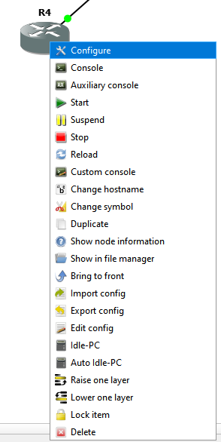

Figure Router Configure

Figure 2 shows Router’s General Configuration Dialogue box

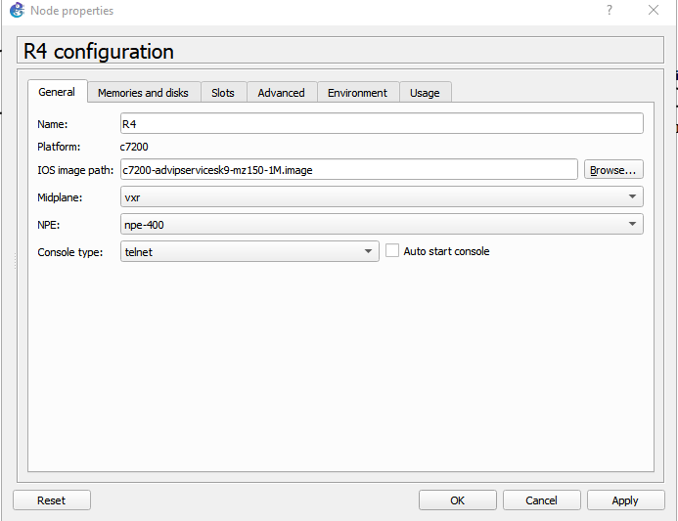

Figure General Configuration

* On Memories and disks, Select PCMCIA disk0, set 32MB

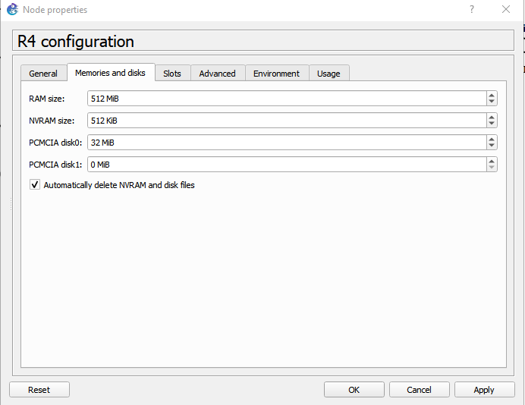

Figure Configure PCMCIA Disk0

Click ok. Disk0 is now configured on the router to be used.

# **Prepare Cisco device for SCP/Candidate Config/Rollback Config**

We must format the added file system on to the router. All operations would be performed by admin user on the router.

* User should be configured with privilege level 15

R4(config)# username netlab privilege 15 secret netlab

* SSH server must be configured on the device to login via ssh.
* To enable SCP (Secure Copy) service on the router.

R4(config)# ip scp server enable

* Configure AAA

R4(config)#aaa new-model

R4(config)#aaa authentication login default local

R4(config)#aaa authorization exec default local none

To check the disk on the router, it is good practice as the disk could be numbered differently.

R4#show all-filesystem [show file systems – command can be used here too]

R4#show disk0

Output cropped for show all-filesystem command in Figure 4.

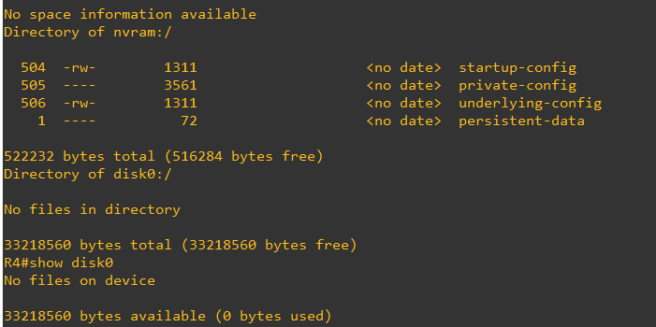

Figure Router Disc information

**Format the disk0**

R4#format disk0:

Figure 5 shows the operation formatting of the disk0 on the router.

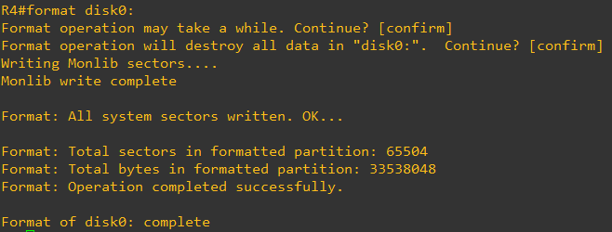

Figure Formatting Disk0

**Confirm SSH is enabled**

R4(config)#ip domain-name netlab.net

R4(config)#crypto key generate rsa 1024

R4(config)#ip ssh version 2

R4(config)#line vty 0 1869

R4(config)#transport input telnet ssh

R4(config)#login local

Router is now ready to be used for SCP(Secure Copy).

Figure 6 shows the script to perform SCP from local desktop to router.

NAPALM uses scp for configuration management.

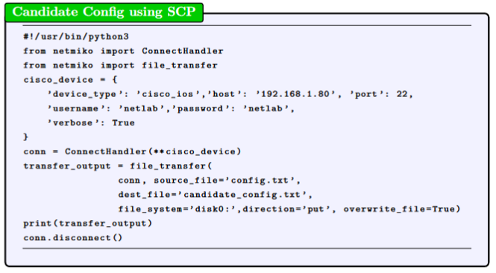

Figure 6 Netmiko SCP Script

Result after running the script is shown in Figure 7.

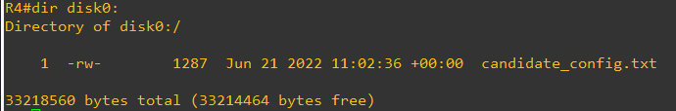

Figure SCP Config from Script

**For Load Replace Configuration**

One most important thing to keep in mind while using NAPALM is, archive and path for the configuration should be given before proceeding.

R4(config)#archive

R4(config-archive)#path disk0:

Figure 8 shows sample script to check if there is any difference in current configuration and configuration file(myconfig.txt). If there is any difference, It will display.

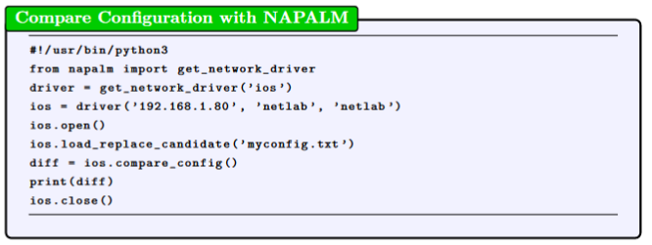

Figure 8 NAPALM Compare Configuration

Further we can create a script which would create a script to replace current configuration if there are any configuration changes are found.

Figure 9 shows us the example.

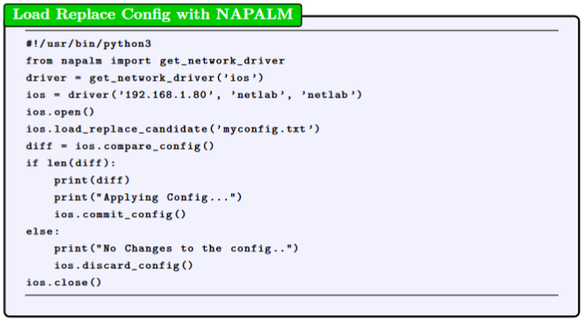

Figure 9 Load Replace Configuration with NAPALM

Figure shows the script to merge configuration with existing config.

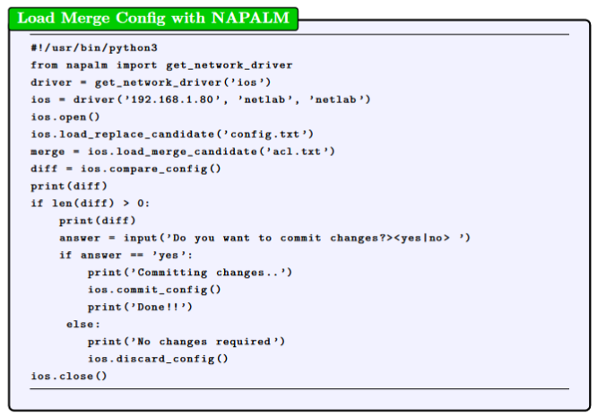

Figure 110 Load Merge Configuration with NAPALM

NAPALM offers great feature to rollback the configuration. In case of misconfiguration, we can rollback the configuration to the old original case.

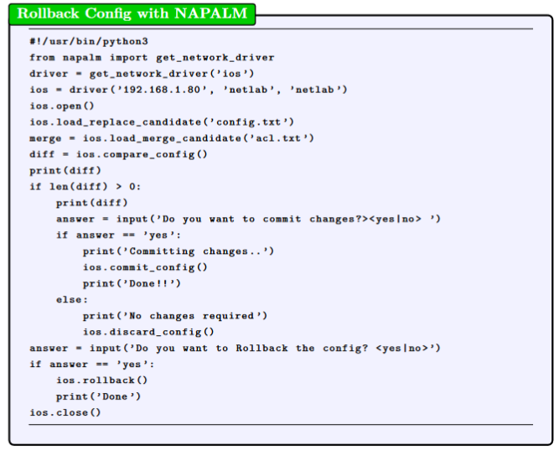

Figure 11 Rollback Configuration with NAPALM

Figure 1 Router Configure 1

Figure 2 General Configuration 2

Figure 3 Configure PCMCIA Disk0 2

Figure 4 Router Disc information 3

Figure 5 Formatting Disk0 4

Figure 6 Netmiko SCP Script 4

Figure 7 SCP Config from Script 5

Figure 8 NAPALM Compare Configuration 5

Figure 9 Load Replace Configuration with NAPALM 6

Figure 10 shows the script to merge configuration with existing config. 6

Figure 10 Load Merge Configuration with NAPALM 6

Figure 11 Rollback Configuration with NAPALM 7

# References

1. “Memory replacement instructions for the network processing engine or network services engine and input/output controller - flash memory card information [CISCO 7200 series routers],” *Cisco*, 12-Oct-2013. [Online]. Available: https://www.cisco.com/c/en/us/td/docs/routers/7200/install_and_upgrade/npe-nse_memory_install/memory/8358ov1.html. [Accessed: 21-Apr-2022].

2. “Changing the configuration,” Changing the Configuration - NAPALM 3 documentation. [Online]. Available: https://napalm.readthedocs.io/en/develop/tutorials/changing_the_config.html. [Accessed: 21-Apr-2022].